Name: Chiranjiv
Date: November 14, 2025
Topic: Basic Linux Commands – Execution and Output

- Creating and Renaming Files/Directories

Explanation:
• mkdir test_dir
This command creates a new directory named test_dir in the current working directory. It's used to organize files into folders.
- touch test_dir/example.txt
This creates an empty file named example.txt inside the test_dir directory. The touch command is commonly used to create new, blank files.
- mv test_dir/example.txt test_dir/renamed_example.txt
This renames the file example.txt to renamed_example.txt within the same directory. The mv command can be used to move or rename files and directories

Screenshot:
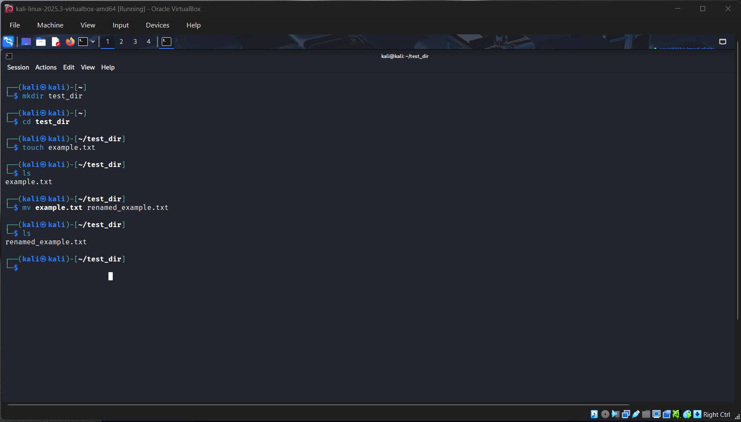

- Viewing File Contents
Explanation:
- cat /etc/passwd
Displays the entire contents of the /etc/passwd file, which contains user account information on Linux systems.
- head -n 5 /etc/passwd
Shows only the first 5 lines of the /etc/passwd file. The head command is useful for previewing the beginning of a file.
- tail -n 5 /etc/passwd
Displays the last 5 lines of the file. The tail command is often used to monitor logs or see recent entries.

Screenshot:
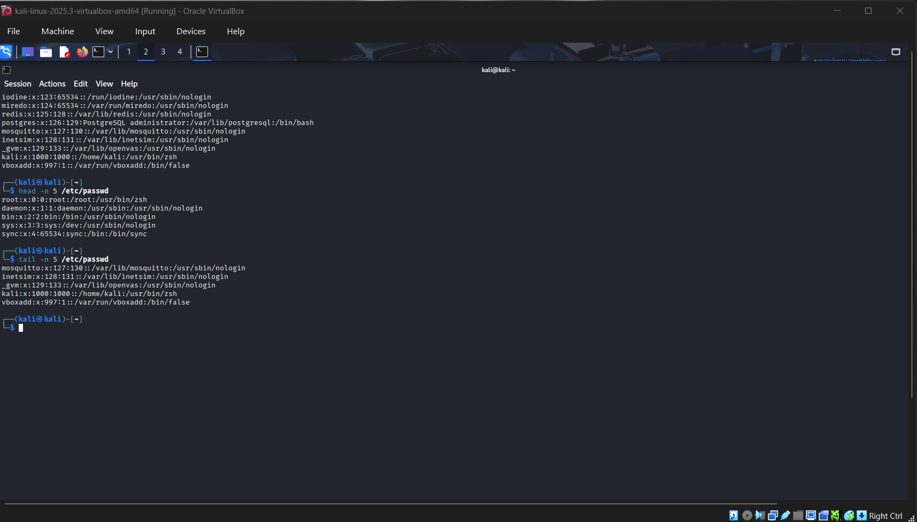

3. Searching for Patterns

Explanation:
- grep "root" /etc/passwd
Searches for and displays all lines in /etc/passwd that contain the word "root". The grep command is a powerful tool for pattern matching and text searching in files
Screenshot:
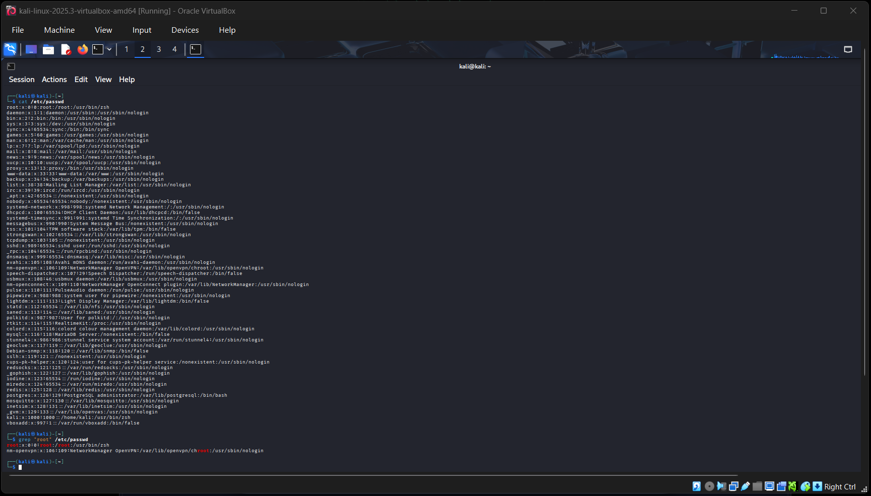

- Zipping and Unzipping

Explanation:
- zip -r test_dir.zip test_dir
This command compresses the entire test_dir directory into a zip archive named test_dir.zip. The -r flag stands for "recursive," meaning it includes all files and subdirectories inside test_dir.
- unzip test_dir.zip -d unzipped_dir
This extracts the contents of test_dir.zip into a new directory called unzipped_dir. The -d option specifies the destination directory

Screenshot:

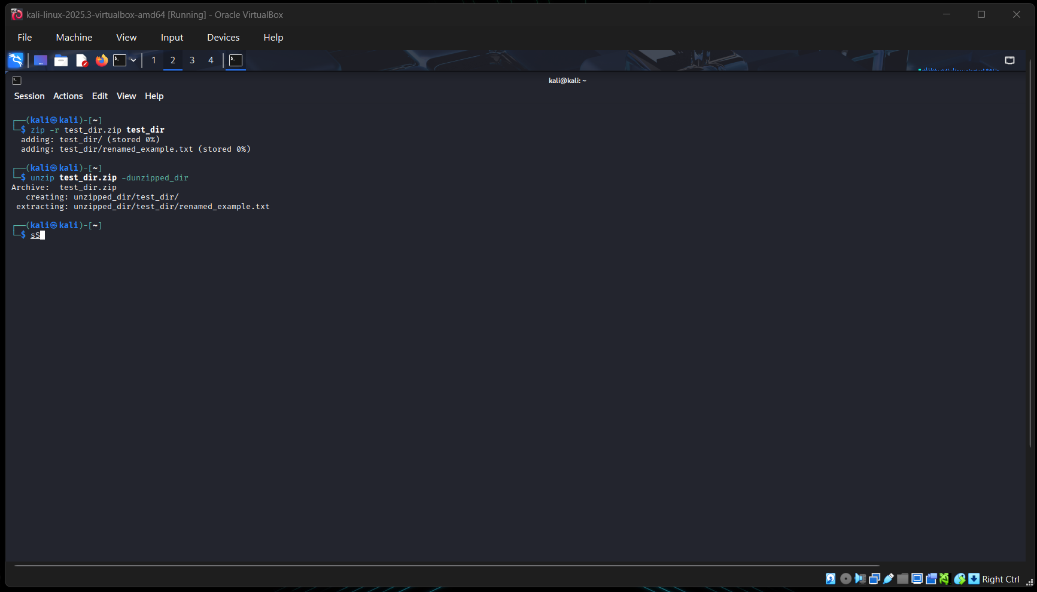
- Downloading Files

Explanation:
- wget https://example.com/sample.txt
This command downloads the file located at the given URL using the wget utility. It saves the file in the current working directory with the same name (sample.txt). wget is useful for retrieving files from web servers via HTTP, HTTPS, or FTP

Screenshot:

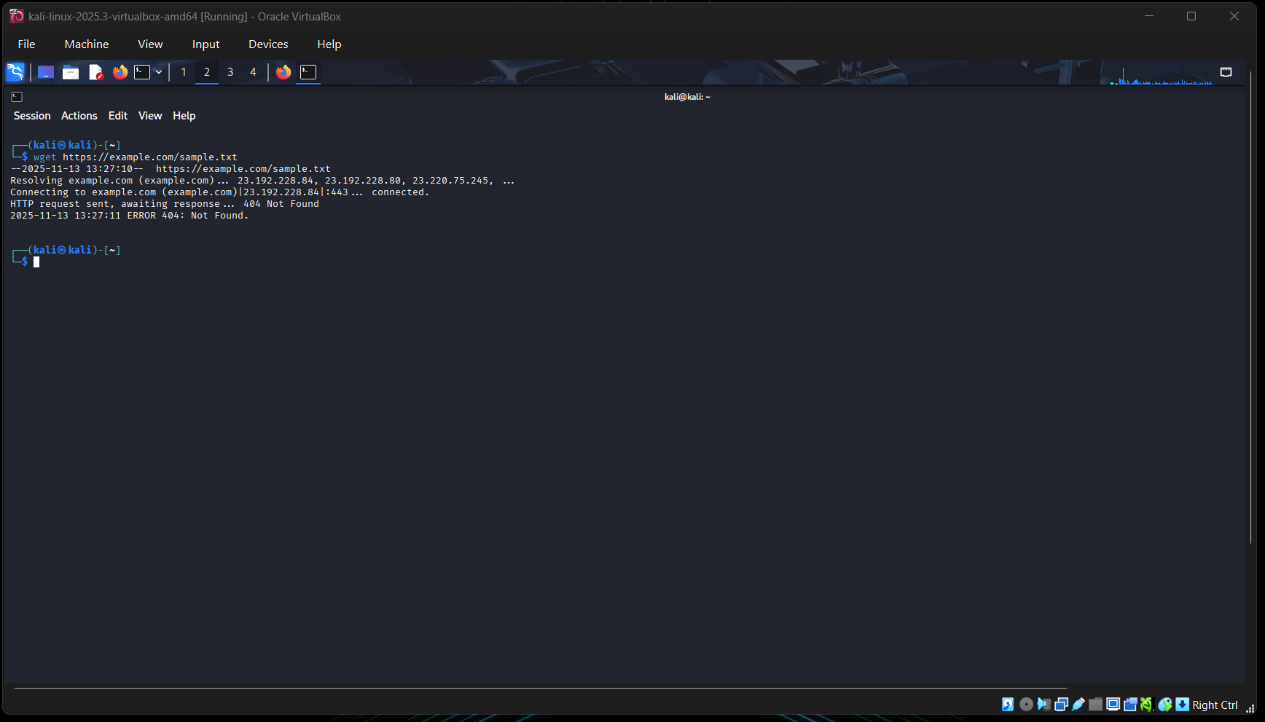
- Changing Permissions

Explanation:
- touch secure.txt
Creates an empty file named secure.txt.
- chmod 444 secure.txt
Changes the file permissions to read-only for everyone:
- Owner: read
- Group: read
- Others: read
The numeric mode 444 ensures that no one can write to or execute the file, making it secure from modification.

Screenshot:

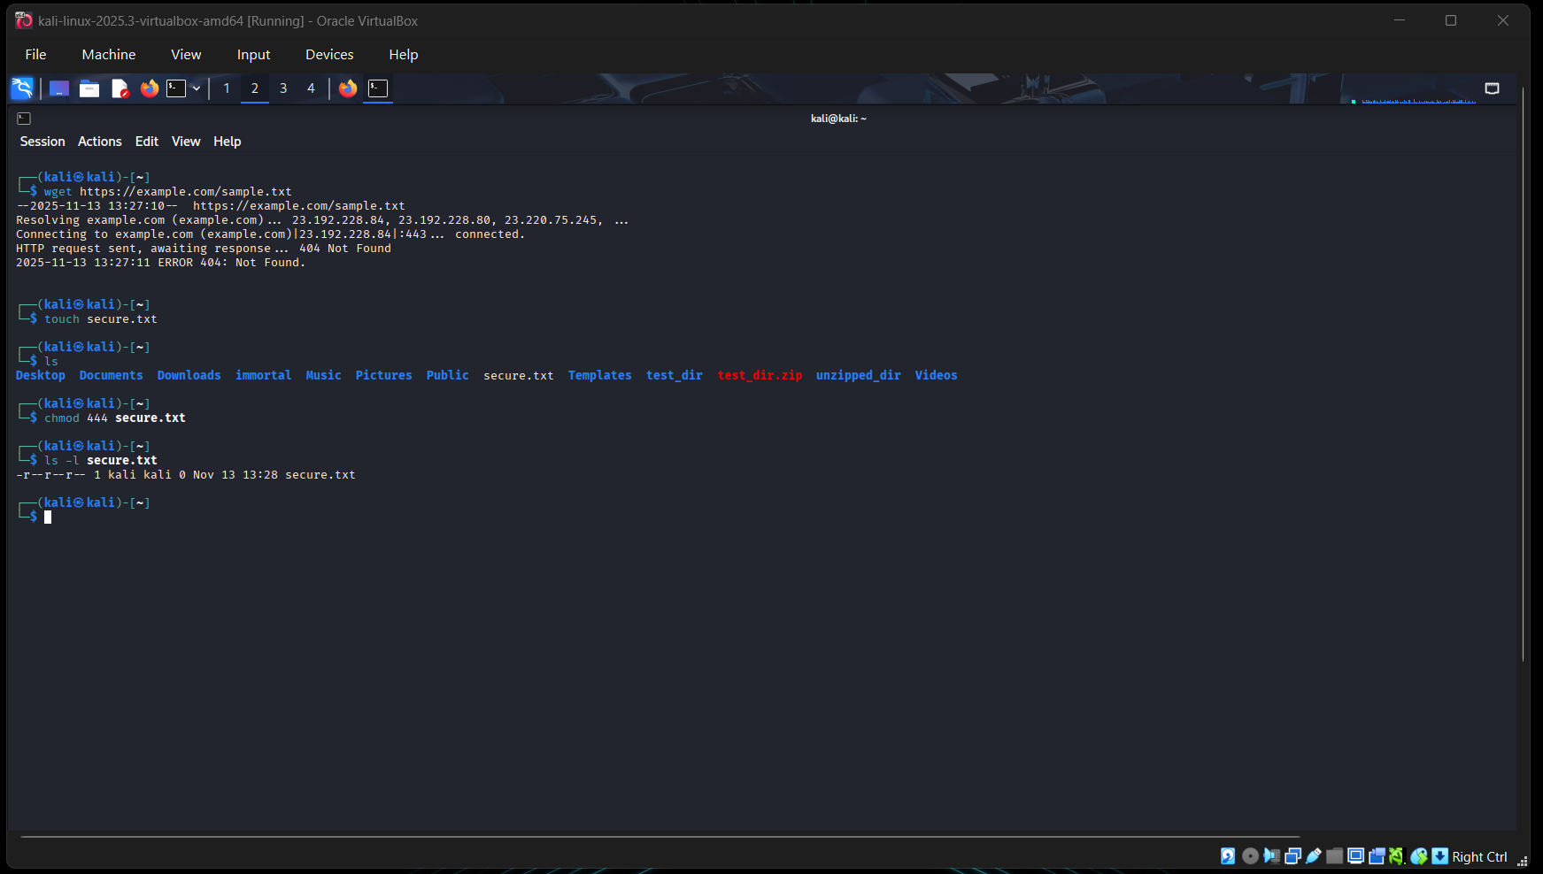
- Working with Environment Variables

Explanation:
- export MY_VAR="Hello, Linux!"
Sets an environment variable named MY_VAR with the value "Hello, Linux!". This variable will be available to the current shell session and any child processes.
- echo $MY_VAR
Displays the value of the environment variable MY_VAR, confirming that it was set correctly.

Screenshot:

